: How to add domains to Live mail:

Login to the live account
You will able to see the dashboard like this.
Click on “Add domain”.

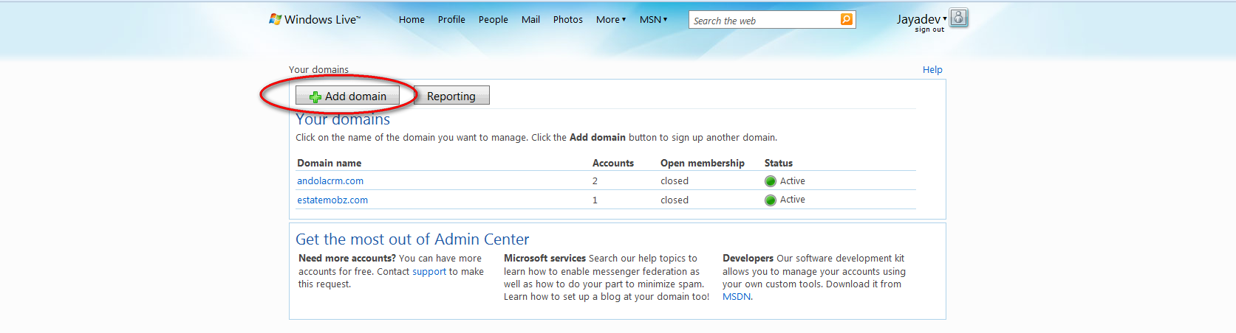

Enter your domain name and click on Continue:

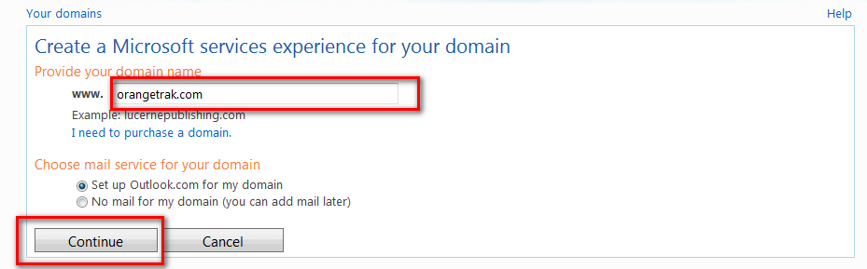

Validate your domain information and enter the security code then click on “I Accept”

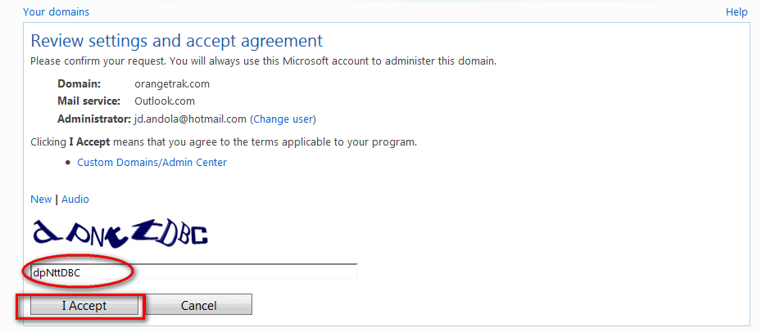
Enter the below DNS records on your DNS account and press “referesh”

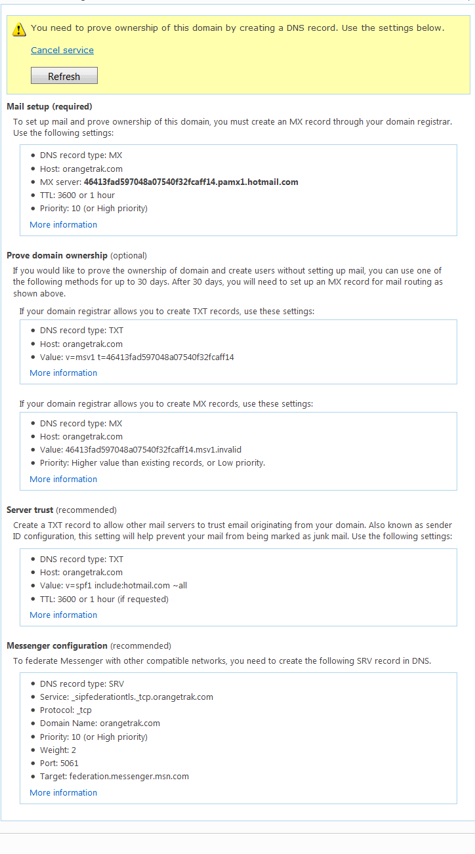

Until DNS propagation you will see the Domain Status as “Pending DNS configuration”

After DNS propagation you will see the Domain status as Active.

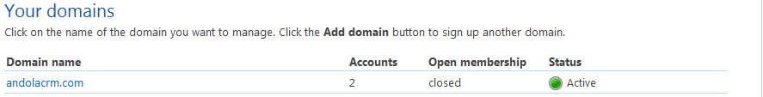

After getting the Active status you can add email accounts to your domain.

How to add email accounts to the domain:

Click on the domain name for which you want to create email account.

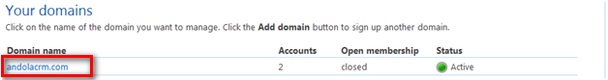

Click on Add

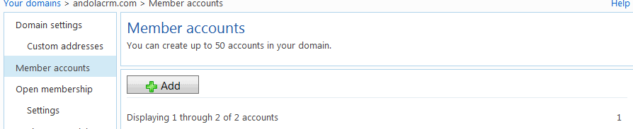

Enter the user informations and Click on OK

